OOFOODIE  
Food Culinary

Blibli ***FUTURE*** Program Batch 4.0

Fase 2 – Medan Kota



Oleh:

Andrew Wijaya

REQUIREMENT DOCUMENT

# Pendahuluan

## Tujuan dan Ruang Lingkup Software

Tujuan dari pembuatan web ini adalah untuk membuat sebuah web yang menunjukkan restoran – restoran terdekat maupun terfavorit.

User dapat me-review dan menambahkan restoran yang akan di validasi oleh admin dari aplikasi. User juga dapat memesan makanan secara online sebelum datang ke restoran tersebut.

Dengan adanya web ooFoodie, masyarakat diharapkan akan lebih mudah untuk mencari restoran dan memesan makanan secara online.

## Definisi

Beberapa definisi kata yang akan sering dipakai :

**Admin** Orang yang dapat mengedit, menambah, atau menghapus data pada sistem; mengakses halaman master.

**Restaurant** Daftar restoran yang ditambahkan oleh User.

**Suggest New Menambahkan Restoran oleh User yang akan di verifikasi oleh Admin**

**Data** Informasi yang berupa fakta; deskripsi dari suatu kejadian yang dihadapi.

**Database** Sistem yang menyimpan semua informasi yang dimonitor oleh sistem ini.

**ERD** *Entity Relationship Diagram*; Diagram yang menunjukkan

**Home** Halaman utama yang ditampilkan sistem.

**Log in** Mengakses sistem dengan memasukkan identitas dari akun pengguna dan kata sandi untuk mendapatkan hak akses akun.

**Log out** Keluar dari akun yang sedang aktif pada sistem.

**Master Data** Data utama yang harus dibuat dengan benar supaya transaksi bisa dilakukan

**Merchant** Pemilik restoran.

**Profile** Berisi informasi User.

**Order** Melakukan pemesanan ke suatu Restoran.

**Top Up Membeli Credit agar dapat mempromosikan restoran**

**Credit** Berguna untuk mempromosikan restoran agar terpapar di “*Popular Restaurant*” dengan jangka waktu tertentu

**Review** Memberi penilaian dan/atau ulasan terhadap suatu restoran.

**Search** Melakukan pencarian produk berdasarkan judul / kata kunci.

**SRS** *Software Requirement Specification*; Suatu dokumen yang mendeskripsikan semua fungsi dari sistem yang diusulkan dan kendala yang terjadi ketika sistem beroperasi, seperti dokumen ini.

**User** Orang yang mengunjungi / menggunakan web sebagai seorang konsumen.

## Referensi

Adapun referensi yang digunakan dalam membantu proses pembuatan dokumen SRS ini :

* [*http://cheesterzone.blogspot.com/2011/04/dokumen-srs-sistem-informasi.html*](http://cheesterzone.blogspot.com/2011/04/dokumen-srs-sistem-informasi.html)
* [*https://hasrulbakri.wordpress.com/2011/05/23/contoh-dokumen-srs-software-requirement-spesification/*](https://hasrulbakri.wordpress.com/2011/05/23/contoh-dokumen-srs-software-requirement-spesification/)
* http://www.cse.msu.edu/~chengb/RE-491/Papers/SRSExample-webapp.doc

## Sistematika

Dokumen SRS ini dibagi menjadi tiga bagian utama, yaitu :

**Pendahuluan**, berisi penjelasan tentang tujuan pembuatan dan lingkup masalah yang dipengaruhi oleh web yang dikembangkan, definisi, referensi dan sistematika.

**Deskripsi Umum**, berisi penjelasan secara umum mengenai web yang akan dikembangkan, meliputi perspektif deskripsi umum sistem,karakteristik pengguna, batasan-batasan dan asumsi penggunaan.

**Spesifikasi Kebutuhan**, berisi uraian kebutuhan web secara lebih rinci.

# Deskripsi Umum

## Perspektif

Produk yang berupa situs web ditujukan kepada para pengguna (konsumen dan para pencari restoran) ooFoodie. Semua pengguna (baik pengguna terdaftar maupun anonim) akan mengakses dengan menggunakan situs web ini.

Pengguna tidak diharuskan mendaftar jika pengguna hanya berkunjung ke web. Namun untuk dapat menggunakan semua fungsi yang disediakan, pengguna diminta untuk mendaftar melalui antarmuka web. Ketika pengguna baru mendaftar, semua data yang diminta akan disimpan dalam database dan sebuah workspace akan diberikan pada pengguna. Nantinya, pengguna dapat melakukan login ke / logout dari sistem kapanpun.

Dari sudut pandang pengguna sebagai konsumen, pengguna diharapkan dapat melihat dan mencari restoran berdasarkan lokasi atau kata kunci, menambahkan restoran baru, dan memesan makanan ke restoran yang ingin dituju secara online. Sementara dari sudut pandang pengguna sebagai pemilik restoran, pengguna diharapkan dapat memasukkan menu makanan, serta melihat daftar pesanan.

## Kegunaan

Produk memungkinkan User dan Merchant untuk melakukan pencarian Restoran secara online.

Fungsi-fungsi dari produk adalah :

|  |  |  |
| --- | --- | --- |
| User | Merchant | Admin |
| Login  Profile  Restaurant Review Search | Login  Restaurant  Incoming Order  Credit | Login  Master Page  Incoming New Restaurant |

## Karakteristik Pengguna

Berikut adalah 3 jenis pengguna beserta karakteristiknya yang akan menggunakanproduk.

|  |  |
| --- | --- |
| **Pengguna** | **Karakteristik** |
| User | User dapat melihat dan mencari restoran yang tersedia, memesan makanan yang terdapat di restoran. Mendaftarkan restoran baru. |
| Merchant | Merchant dapat menambahkan menu makanan dari restoran yang dipunya |
| Admin | Admin dapat mengubah data, mengakses halaman master. |

## Batasan-Batasan

Beberapa batasan dalam menggunakan web ini :

* Sistem hanya dapat digunakan pada perangkat dengan *browser* yang mendukung JavaScript, seperti Chrome vers. 51, Firefox vers. 54, Edge vers. 14, Safari vers. 10, dan Opera vers. 38.
* User yang dapat meilhat restoran – restoran yang terdapat dalam sistem, mendaftarkan restoran baru yang akan di verifikasi oleh admin, memesan makanan dari restoran secara online, review restoran.
* Merchant yang sudah terdaftar hanya dapat menambahkan menu makanan dari restoran yang dimilikinya.
* Admin dapat akses ke master data.

## Asumsi dan Ketergantungan

Asumsi dan ketergantungan dalam menggunakan web ini :

* Pengguna sudah mengerti dalam memakai layanan *e-commerce*
* Semua pembayaran yang dilakukan secara otomatis akan berhasil

# Spesifikasi Kebutuhan

## Kebutuhan Fungsional

Berikut adalah Use Case Diagram dari masing-masing role.

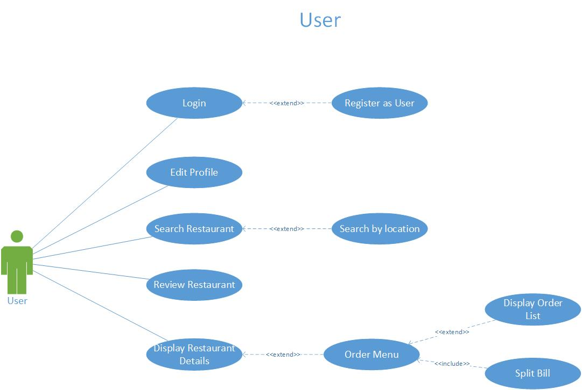

Gambar 1 Use Case Diagram for User

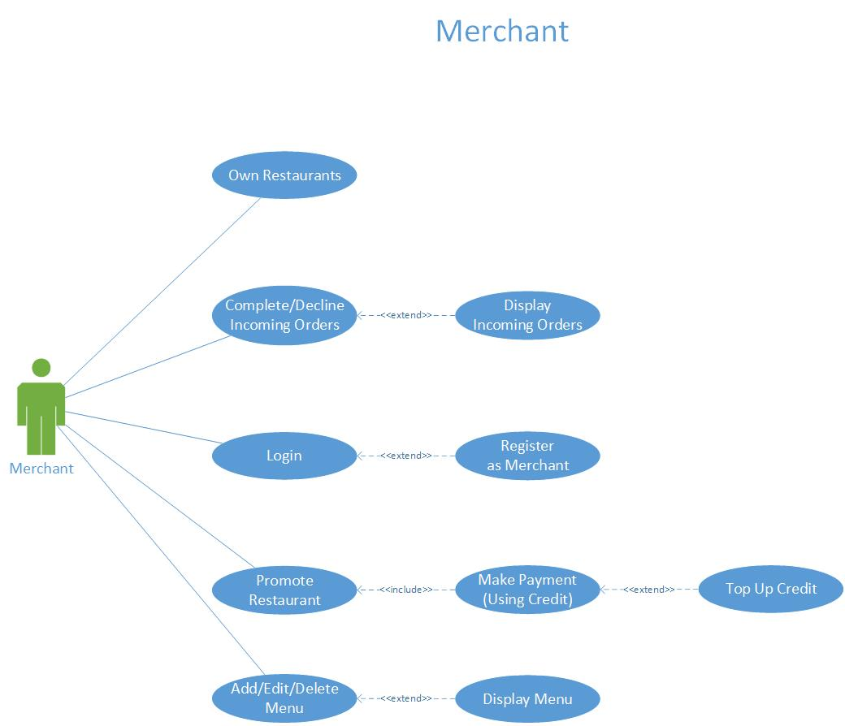

Gambar 2 Use Case Diagram for Merchant

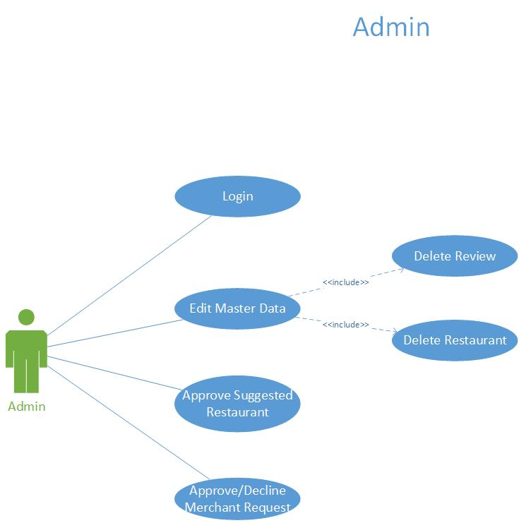

Gambar 3 Use Case Diagram for Admin

Berikut deskripsi dari Use Case Diagram di atas.

### Log in

|  |  |  |
| --- | --- | --- |
| Use Case Name | Log in | |
| Scenario | Login an account to use the web | |
| Triggering Event | Clicking some features that only available to verified account.  Clicking Log in / Register menu. | |
| Brief Description | User must log in to use all of the provided features and have an account.  Merchant and Admin must log in before using the web and have an account. | |
| Actors | User, Merchant, Admin | |
| Pre-conditions | User, Merchant, Admin hasn’t logged in | |
| Post-conditions | User, Merchant, Admin has logged in | |
| Flow of Activities | **Actor** | **System** |
| 1. User, Merchant, Admin click Log in / Register menu | * 1. System loads the UI for login |
| 1. User, Merchant, Admin type the username and password |  |
| 1. User, Merchant, Admin click on login button | * 1. System validates the username and password   2. System informs the user of successful login by show the home UI for each role.   3. System loads the home UI. |
| Exceptions Conditions | * 1. User, Merchant, Admin failed to Log in due to unstable Internet connection.   2. User, Merchant, Admin failed to Log in caused by wrong username / password.   3. User, Merchant failed to Log in because the account is blocked from the system. | |

### Register as User / Merchant

|  |  |  |
| --- | --- | --- |
| Use Case Name | Register as User / Merchant | |
| Scenario | Register as an User / a Merchant | |
| Triggering Event | Clicking Log in / Register menu.  Clicking Register menu. | |
| Brief Description | User / Merchant input all the required field such as username, full name, email, password. | |
| Actors | User, Merchant | |
| Pre-conditions | User, Merchant hasn’t have an account | |
| Post-conditions | User, Merchant has an account and has logged in. | |
| Flow of Activities | **Actor** | **System** |
| 1. User / Merchant click Log in / Register menu | * 1. System loads the UI for login |
| 1. User / Merchant type all the required information, such as username and password. |  |
| 1. User / Merchant click on Sign up button | * 1. System validates all the field in form   2. System successfully registered an account in database   3. System automatically logged in the User / Merchant by show the home UI for each role. |
| Exceptions Conditions | 3.2. User / Merchant failed to register due to an error in some field, such as username already exists. | |

### Edit Profile

|  |  |  |
| --- | --- | --- |
| Use Case Name | Edit Profile | |
| Scenario | View or Edit Profile of an User account | |
| Triggering Event | Clicking Profile menu from Tab Bar.  Clicking Edit Profile. | |
| Brief Description | User fill/edit their personal information such as Address, Phone Number, etc. | |
| Actors | User | |
| Pre-conditions | User hasn’t complete / change their personal information | |
| Post-conditions | User has completed / changed their personal information | |
| Flow of Activities | **Actor** | **System** |
| 1. User click Profile menu | * 1. System loads the UI for edit profile |
| 1. User fill / change some or all the required information, such as Address, Phone Number. |  |
| 1. User click on checklist (Done) button. | * 1. System successfully filled / changed the information in database   2. System redirects to Home UI |
| Exceptions Conditions | 3.1. User failed to change / fill the information due to unstable Internet connection. | |

### Edit Menu

|  |  |  |
| --- | --- | --- |
| Use Case Name | Edit Menu | |
| Scenario | View or Edit Menu of a Restaurant. | |
| Triggering Event | Clicking Edit button. | |
| Brief Description | Merchant fill/edit their menu such as Menu Name. | |
| Actors | Merchant | |
| Pre-conditions | Merchant hasn’t complete / change their Menu. | |
| Post-conditions | Merchant has completed / changed their Menu. | |
| Flow of Activities | **Actor** | **System** |
| 1. Merchant click the Edit button on Menu List Page. | * 1. System loads the UI for edit Menu. |
| 1. Merchant fill / change some or all the required information, such as Name and Image. |  |
| 1. Merchant click on checklist (Save) button. | * 1. System successfully filled / changed the information in database   2. System redirects to Storefront UI. |
| Exceptions Conditions | * 1. Merchant failed to change / fill the information due to unstable Internet connection. | |

### Search Restaurant

|  |  |  |
| --- | --- | --- |
| Use Case Name | Search Restaurant | |
| Scenario | Search restaurant by Keyword or Location. | |
| Triggering Event | Clicking Wishlist menu on Tab bar. | |
| Brief Description | User be able to view Restaurant by Keyword or Location. | |
| Actors | User | |
| Pre-conditions | Admin hasn’t removed Restaurant. | |
| Post-conditions | User get the Restaurant List. | |
| Flow of Activities | **Actor** | **System** |
| 1. User click the Search menu from Tab Bar. | * 1. System loads the UI to input keyword or drop location. |
| 1. User type the keyword or drop a pin point. | * 1. System search by keyword or location. |
| Exceptions Conditions | * 1. User failed to search because of internet connection. | |

### Review Restaurant

|  |  |  |
| --- | --- | --- |
| Use Case Name | Review Restaurant | |
| Scenario | Review Restaurant and give Rating. | |
| Triggering Event | Clicking “Review” button at Restaurant Page. | |
| Brief Description | User be able to review a Restaurant and give rating. | |
| Actors | User | |
| Pre-conditions | User hasn’t reviewed the Restaurant. | |
| Post-conditions | User has reviewed the Restaurant and give a rating. | |
| Flow of Activities | **Actor** | **System** |
|  | 1. User click a Restaurant that will be reviewed. | * 1. System redirect to Restaurant Page. |
| 1. User click on Review Button or star button. | * 1. System show review form. |
| 1. User input comment and star and click save. | * 1. System close the form. |
| Exceptions Conditions | * 1. User failed to review the Restaurant due to unstable Internet connection. | |

### Order Menu

|  |  |  |
| --- | --- | --- |
| Use Case Name | Order Menu | |
| Scenario | Order Menu from a Restaurant. | |
| Triggering Event | Clicking Order Now Button on Restaurant page. | |
| Brief Description | User be able to order menu. | |
| Actors | User | |
| Pre-conditions | User hasn’t Ordered. | |
| Post-conditions | User has ordered. | |
| Flow of Activities | **Actor** | **System** |
| 1. User click the Order Menu button on Top Right. | * 1. System loads the UI. |
| 1. User choose the menu and submit. | * 1. System destroy the modal. |
| Exceptions Conditions | * 1. User failed to order menu due to unstable Internet connection. | |

### Split Bill

|  |  |  |
| --- | --- | --- |
| Use Case Name | Split Bill | |
| Scenario | Split Bill to another user via email. | |
| Triggering Event | Clicking Split Bill on Order Menu modal. | |
| Brief Description | User be able to split bill to another friend. | |
| Actors | User | |
| Pre-conditions | User has ordered menu. | |
| Post-conditions | User has sent bill via email. | |
| Flow of Activities | **Actor** | **System** |
| 1. User open Order Menu modal. | * 1. System load modal |
| 1. User click on Split Bill button | * 1. System change modal to Split Bill |
|  | 1. User input email and click send | * 1. System send bill to email. |
| Exceptions Conditions | * 1. User failed to send email due to internet connection.   2. User failed to send email due to wrong email address. | |

### Accept / Decline Incoming Orders

|  |  |  |
| --- | --- | --- |
| Use Case Name | Accept / Decline Incoming Orders | |
| Scenario | Accept / Decline Incoming Orders from user. | |
| Triggering Event | Clicking Accept / Decline button on Incoming Orders page. | |
| Brief Description | Merchant be able to Accept / Decline Incoming Orders from user. | |
| Actors | Merchant | |
| Pre-conditions | Merchant hasn’t made action. | |
| Post-conditions | Merchant has made decision to Accept / Decline. | |
| Flow of Activities | **Actor** | **System** |
| 1. Merchant click on Accept / Decline Button | * 1. System update data. |
| Exceptions Conditions | 2.1. User Accept / Decline due to unstable Internet connection. | |

### Promote Restaurant

|  |  |  |
| --- | --- | --- |
| Use Case Name | Promote Restaurant | |
| Scenario | Promote a Restaurant to Home Page. | |
| Triggering Event | Clicking promote button on Restaurant Page. | |
| Brief Description | Merchant be able to promote a Restaurant he owns. | |
| Actors | User | |
| Pre-conditions | Merchant hasn’t promoted the restaurant. | |
| Post-conditions | User has promoted the restaurant. | |
| Flow of Activities | **Actor** | **System** |
| 1. User click on promote button | * 1. System submit |
| Exceptions Conditions | 3.1. User failed to promote the restaurant due to unstable Internet connection. | |

### Add / Edit / Delete Menu

|  |  |  |
| --- | --- | --- |
| Use Case Name | Add / Edit / Delete Menu | |
| Scenario | Merchant be able to Add / Edit / Delete the Menu. | |
| Triggering Event | Merchant clicking the Add / Edit / Delete menu button | |
| Brief Description | Merchant be able to Add / Edit / Delete the Menu that he owns. | |
| Actors | Merchant | |
| Pre-conditions | Merchant had added the restaurant. | |
| Post-conditions | Merchant has Add / Edit / Delete the Menu. | |
| Flow of Activities | **Actor** | **System** |
| 1. Merchant click on Add / Edit / Delete Menu button | * 1. System loads the UI |
| 1. User fill in the form to edit and submit. | * 1. System submit the data and edit it. |
| Exceptions Conditions | * 1. User failed to Add / Edit / Delete the menu due to unstable Internet connection. | |

### Delete a Review

|  |  |  |
| --- | --- | --- |
| Use Case Name | Delete a Review | |
| Scenario | Admin delete an inappropriate review. | |
| Triggering Event | Clicking Delete Review button on admin page. | |
| Brief Description | Admin be able to delete a review. | |
| Actors | Admin | |
| Pre-conditions | Admin hasn’t deleted the review. | |
| Post-conditions | Admin has deleted the inappropriate review. | |
| Flow of Activities | **Actor** | **System** |
| 1. Admin click on Delete Review Button | * 1. System will update the data. |
| Exceptions Conditions | 3.1. Admin failed to delete the review due to unstable Internet connection. | |

### Delete Restaurant

|  |  |  |
| --- | --- | --- |
| Use Case Name | Delete a Review | |
| Scenario | Admin delete a inappropriate restaurant. | |
| Triggering Event | Clicking Delete Restaurant button on admin page. | |
| Brief Description | Admin be able to delete a restaurant. | |
| Actors | Admin | |
| Pre-conditions | Admin hasn’t deleted the restaurant. | |
| Post-conditions | Admin has deleted the inappropriate restaurant. | |
| Flow of Activities | **Actor** | **System** |
| 1. Admin click on Delete Restaurant Button | * 1. System will update the data. |
| Exceptions Conditions | 3.1. Admin failed to delete the restaurant due to unstable Internet connection. | |

### Approve / Decline Merchant Request

|  |  |  |
| --- | --- | --- |
| Use Case Name | Approve / Decline Merchant Request | |
| Scenario | Approve / Decline Merchant Request to verify the merchant. | |
| Triggering Event | Clicking Approve / Decline Merchant Button | |
| Brief Description | Admin be able to Approve / Decline Merchant registration request. | |
| Actors | Admin | |
| Pre-conditions | Admin hasn’t Approve / Decline the Merchant registration request. | |
| Post-conditions | Admin has Approve / Decline Merchant registration request. | |
| Flow of Activities | **Actor** | **System** |
| 1. Admin clicking on Approve / Decline Merchant registration request Button | * 1. System update the data. |
| Exceptions Conditions | * 1. Admin failed to Approve / Decline Merchant Registration Request due to internet connection problems. | |

## Kebutuhan Antarmuka Eksternal

### Kebutuhan Antarmuka Pengguna

Antarmuka pengguna harus bisa berinteraksi dengan antarmuka yang ditampilkan sistem pada layar *smartphone* Android (utama), laptop, komputer, tablet, dan sebagainya.

### Kebutuhan Antarmuka Perangkat Keras

Perangkat keras yang digunakan harus mampu untuk terhubung dengan koneksi internet, serta memiliki daya yang cukup.

### Kebutuhan Antarmuka Perangkat Lunak

Perangkat lunak yang dibutuhkan untuk mengoperasikan perangkat lunak ialah:

* Sistem Operasi

Laptop, komputer : Windows 10

* Browser : Chrome
* Database : PostgreSQL 11

### Kebutuhan Antarmuka Komunikasi

Tidak diterapkan pada sistem ini.

## Kebutuhan Non-Fungsional

### Struktur Logikal Data

### 

Gambar 4 Entity-Relationship Diagram

# User Stories

#### User

Sebagai seorang User, saya ingin melakukan login / logout dari akun saya.

Sebagai seorang User, saya ingin mengedit profil / akun saya.

Sebagai seorang User, saya ingin mencari restoran berdasarkan kata kunci atau lokasi.

Sebagai seorang User, saya ingin memberi ulasan terkait restoran.

Sebagai seorang User, saya ingin memesan makanan secara online.

Sebagai seorang User, saya ingin mengirim bill ke email tujuan.

#### Merchant

Sebagai seorang Merchant, saya ingin menerima atau menolak pemesanan makanan.

Sebagai seorang Merchant, saya ingin melakukan login / logout dari akun saya.

Sebagai seorang Merchant, saya ingin mempromosikan restoran saya.

Sebagai seorang Merchant, saya ingin menambahkan credit.

Sebagai seorang Merchant, saya ingin menambahkan, mengubah dan menghapus menu.

#### Admin

Sebagai seorang Admin, saya ingin melakukan Login / Logout pada akun saya.

Sebagai seorang Admin, saya ingin menghapus ulasan.

Sebagai seorang Admin, saya ingin menghapus restoran.

Sebagai seorang Admin, saya ingin menerima atau menolak permohonan Merchant untuk mendaftar

Sebagai seorang Admin, saya ingin menerima usulan restoran baru.